Question 1

$$\left[\begin{matrix}\cos\left(k\right) & \sin\left(k\right) & 0 \\ -\sin\left(k\right) & \cos\left(k\right) & 0 \\ 0 & 0 & 1\end{matrix}\right]\left[\begin{matrix}1 & 0 & -x_{0} \\ 0 & 1 & -y_{0} \\ 0 & 0 & 1\end{matrix}\right]\left[\begin{aligned}x \\ y \\ 1\end{aligned}\right]$$

= $\left[\begin{matrix}\cos\left(k\right) & \sin\left(k\right) & \cos\left(k\right)\left(-x_{0}\right)+\sin\left(k\right)(-y_{0}) \\ -\sin\left(k\right) & \cos\left(k\right) & -\sin\left(k\right)\left(-x_{0}\right)+\cos\left(k\right)(-y_{0}) \\ 0 & 0 & 1\end{matrix}\right]\left[\begin{aligned}x \\ y \\ 1\end{aligned}\right]$

Where $k=\arctan\left(\frac{y_{1}-y_{0}}{x_{1}-x_{0}}\right)$.

If ($x_{1}-x_{0}$, $y_{1}-y_{0}$) is in the second or third quadrant, subtract pi from k before computing.

Question 2

Take Q, subtract b from its y-component. Rotate the point by -θ, negate the y-component of the point, rotate it back by θ, and add b to the y-component of this point. The resulting point is Q­­’. We then need to find the y-intercept of QQ­­’. Compute the slope m = $\frac{Q_{y}-{Q'}_{y}}{Q_{x}-{Q'}_{x}}$. Then, setting x=0 in point-slope form, we get the equation y = m(-Qx­) + Q­y. Now, we have all we need to find P­­’.Take P, subtract y (the intercept of QQ­­’) from the y-component of P, rotate the point by $\frac{π}{2}-θ$, negate the y-component of this resulting point, rotate by -( $\frac{π}{2}-θ$), and then add y back to the y-component. This point is P­­’.

Question 3

C1

A1

B1

X

Y

B

A

C

A2

B2

C2

A1 = (-2,0), B1 = (-3,0), C1 = (-2,1)

A2 = (1/2,-1), B2 = (1,-1), C2 = (1/2,-3)

Question 4

Each viewport is the result of three transformations.

Viewpoint 1: T(1, 3) * D(1/2, 3/4) * T(-2, -2)

Viewpoint 2: T(4, 5) * D(3/4, 1/2) * T(-2, -2)

A’ = (1.5, 5.25), B’ = (2, 5.625), C’ = (2.5, 4.5)

A’’ = (4.75, 6.5), B’’ = (5.5, 6.75), C’’ = (6.25, 6)

**Window**

**6**

**5**

**7**

**2**

**6**

**A**

**B**

**C**

**3**

**B’’**

**A’’**

**C’**

**B’**

**A’**

**C’**

**2**

**6**

**3**

**2**

**1**

**4**

**7**

Question 5

P1

P2

P3

P4

P6

P7

P8

P5

Clipping Window

Polygon

Sutherland-Hodgman Algorithm:

Output Vertex List: {P3’, P4, P4’, P6’, P7, P7’}

* The prime (‘) vertices are where the line intersects the clipper region

Weiler-Atherton Algorithm

Output Vertex Lists: {P3’, P4, P4’} and {P6’, P7, P7’}

* The prime (‘) vertices are where the line intersects the clipper region

Question 6

* The “E” indicates a change to even, the “O” a change to odd, going from left to right

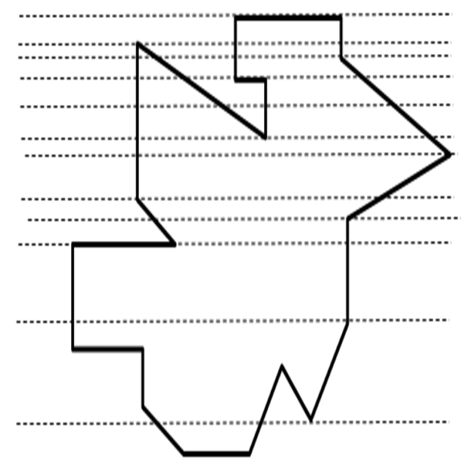

**E**

**E**

**O**

**E**

**O**

**E**

**E**

**O**

**E**

**E**

**O**

**E**

**E**

**O**

**E**

**E**

**O**

**E**

**E**

**O**

**E**

**E**

**O**

**E**

**O**

**E**

**E**

**O**

**E**

**O**

**E**

**E**

**O**

**E**

**O**

**E**

**E**

**E**

**E**

**O**